**CSC8502 – Advanced Graphics for Games  
Jack Hookham**

<https://www.youtube.com/watch?v=D6cVMhjHEhg>

**Controls**Toggle Info: I  
Cycle Scene: Left/Right  
Pause Cycle: P  
Free Camera: C  
Camera Controls: WASD + Mouse  
Camera Speed: Up/Down  
Increase Sobel: U  
Recompile Shaders: R  
Planet Movement: T  
Erupt Volcano: E  
Volcano Multi Cam: M  
Volcano camera selection: 1 - 4  
Mountain Day/Night: T

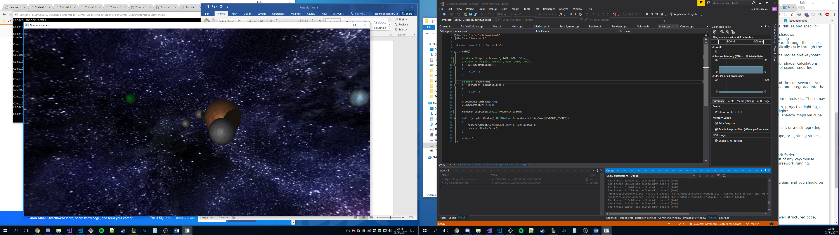Real time omnidirectional shadow map via cube mapping  
Sun, planet, moon scene node hierarchy

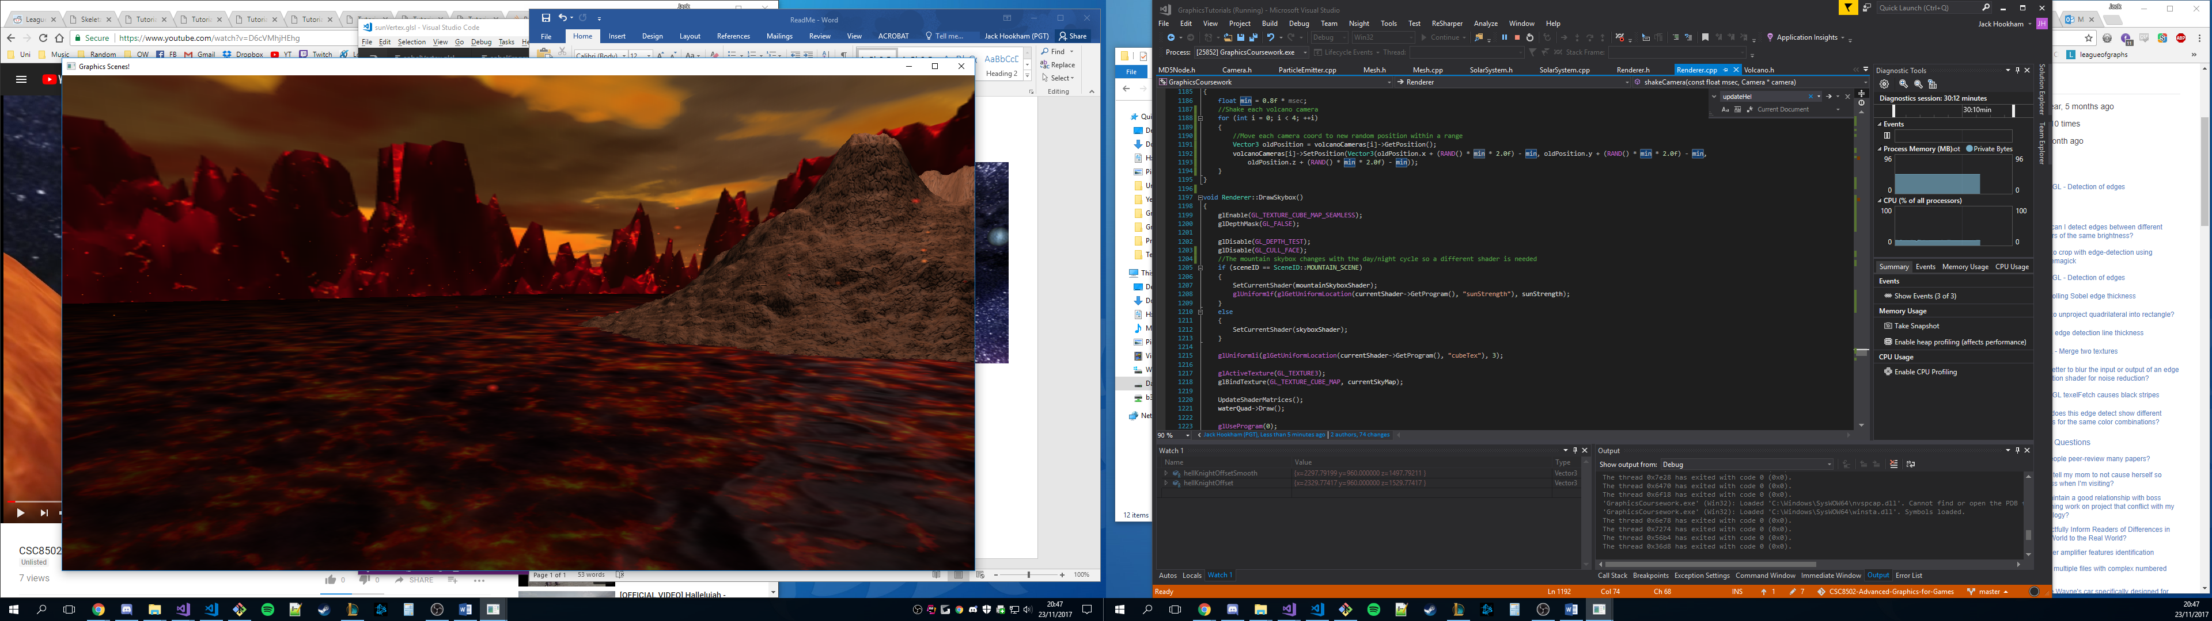  
Jumping lava particles  
Bump mapped lava with lighting calculations  
Bump mapped terrain with lighting calculations

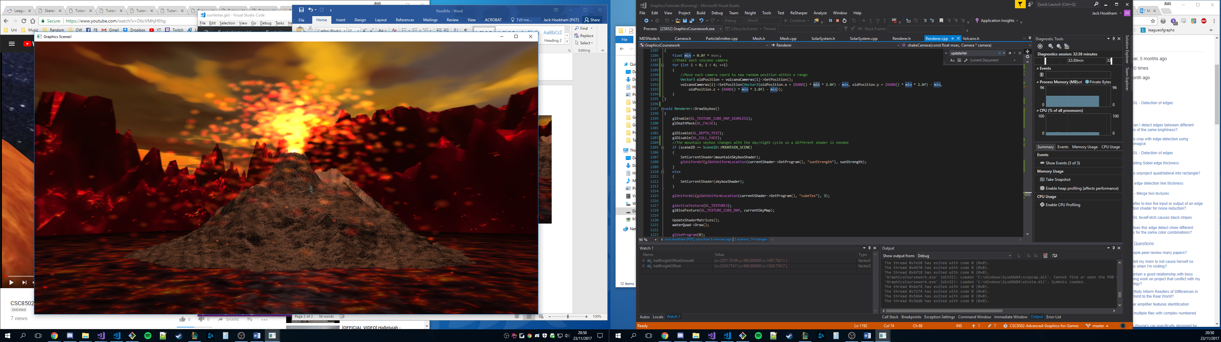  
Erupting volcano – particles and camera shake

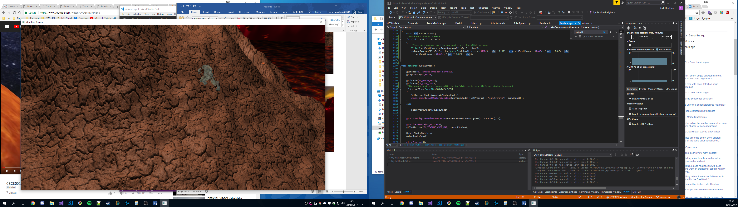  
Walking, animated Hell Knight model  
Moves up and down based on height map Y coord

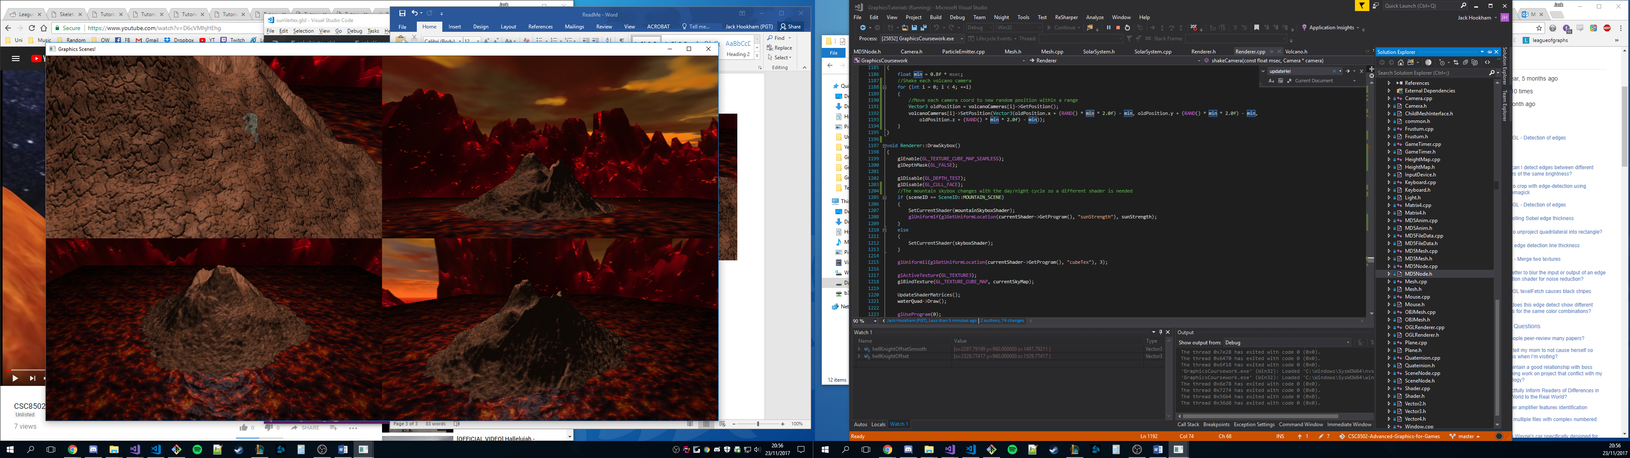  
Multiple cameras using viewports  
Each camera can be selected and moved independently using keys 1 - 4  
  
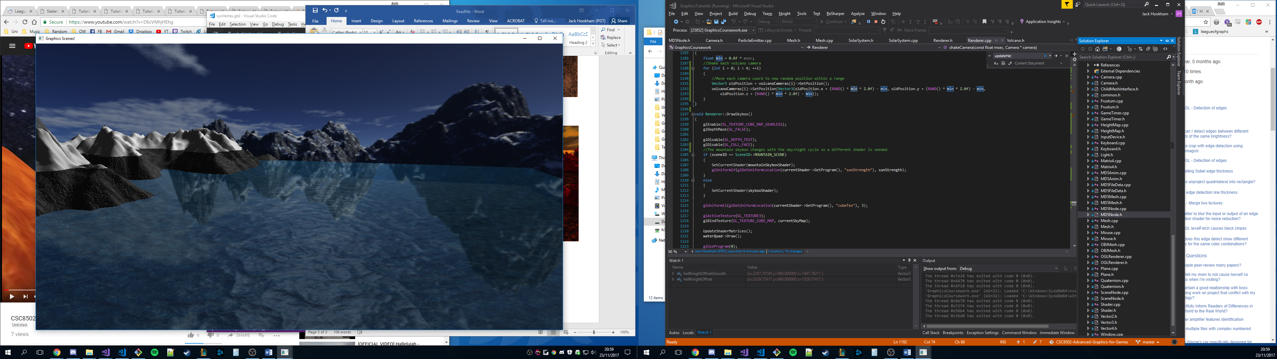  
Water with height map reflection and bump mapping  
Water rises and lowers and texture matrix is changed to create a tidal effect  
Day/night cycle with real time lighting  
Sky box gets lighter/darker with day/night

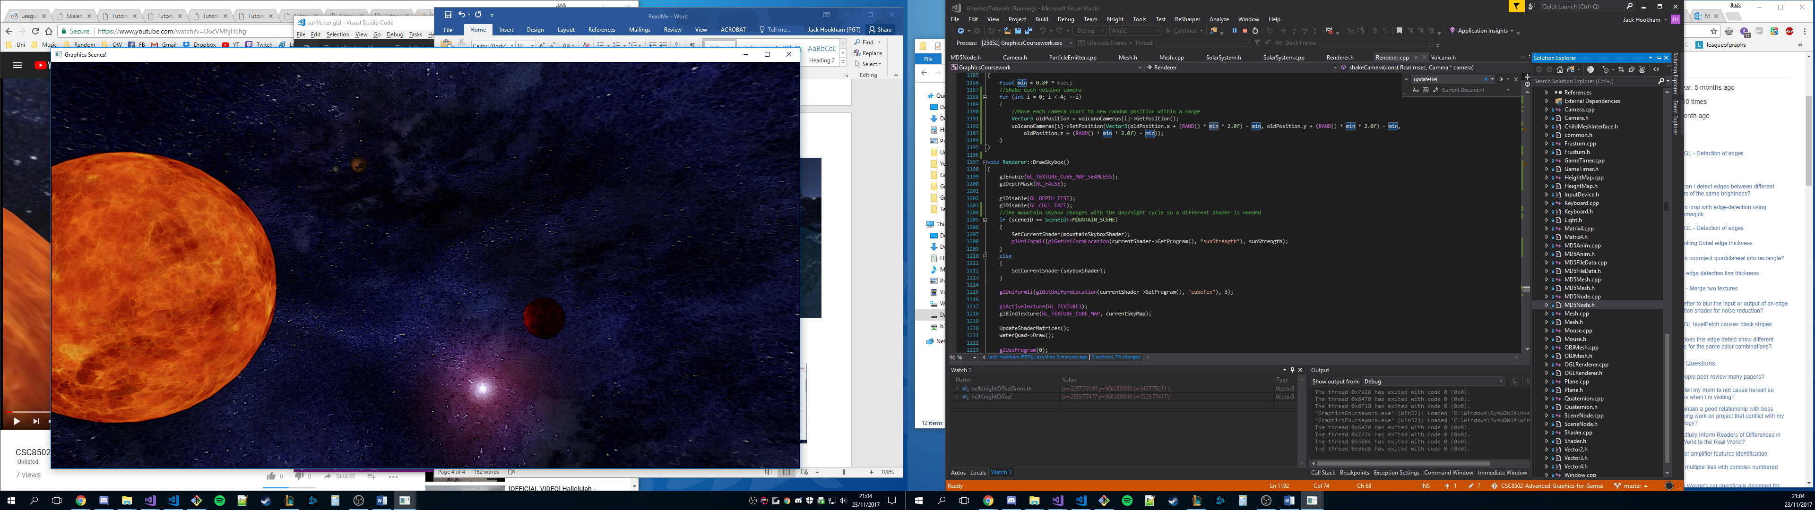  
Pressing U increases sobel factor by 0.1 up to a maximum of 1.0  
Starts to get too dark above 0.3

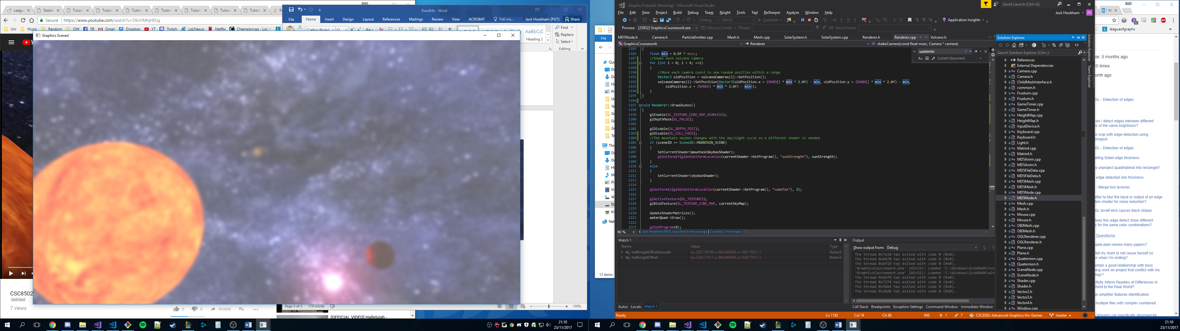  
Scene transition blurs then fades to white